BIRD IMPACT ASSESSMENT STUDY

Eskom Transmission

AVIFAUNAL IMPACT ASSESSMENT:
RUSTENBURG STRENGTHENING PHASE 2 (MARANG B)

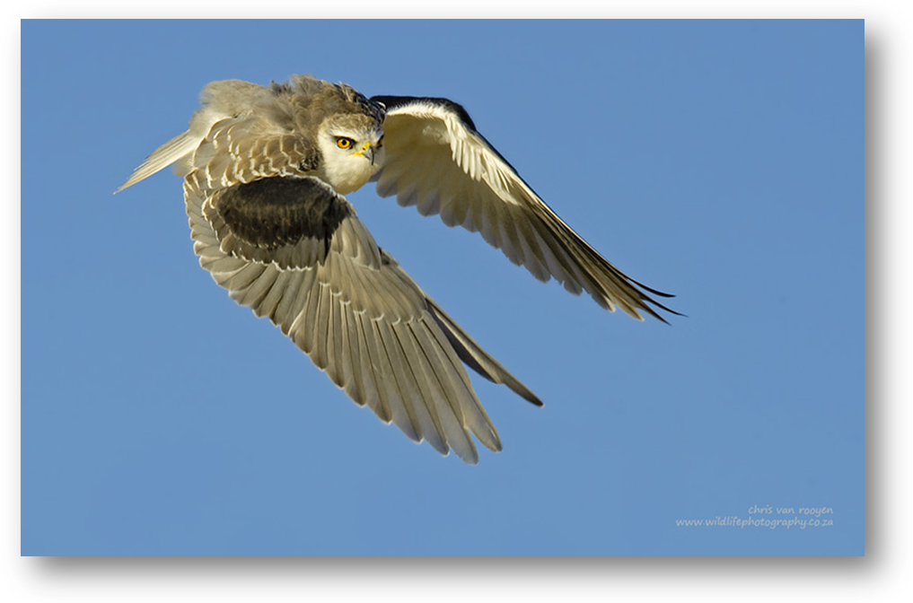

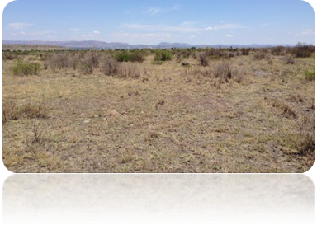

FEBRUARY 2014

Prepared by:

Chris van Rooyen Consulting
30 Roosevelt Street
Robindale
Randburg
2194
South Africa
Tel. International: +27824549570
Tel. Local: 0824549570
Fax: 0866405205
Email: vanrooyen.chris@gmail.com

Chris van Rooyen
Chris has seventeen years’ experience in the management of wildlife interactions with electricity infrastructure. He was head of the Eskom-Endangered Wildlife Trust (EWT) Strategic Partnership from 1996 to 2007, which has received international acclaim as a model of co-operative management between industry and natural resource conservation. He is an acknowledged global expert in this field and has worked in South Africa, Namibia, Botswana, Lesotho, New Zealand, Texas, New Mexico and Florida. Chris also has extensive project management experience and has received several management awards from Eskom for his work in the Eskom-EWT Strategic Partnership. He is the author of 15 academic papers (some with co-authors), co-author of two book chapters and several research reports. He has been involved as ornithological consultant in more than 100 power line and 25 wind generation projects. Chris is also co-author of the Best Practice for Avian Monitoring and Impact Mitigation at Wind Development Sites in Southern Africa, which is currently (2013) accepted as the industry standard. Chris also works outside the electricity industry and had done a wide range of bird impact assessment studies associated with various residential and industrial developments.

Albert Froneman (Pr.Sci.Nat)
Albert has an M. Sc. in Conservation Biology from the University of Cape Town, and started his career in the natural sciences as a Geographic Information Systems (GIS) specialist at Council for Scientific and Industrial Research (CSIR). He is a registered Professional Natural Scientist in the field of zoological science with the South African Council of Natural Scientific Professionals (SACNASP). In 1998, he joined the Endangered Wildlife Trust where he headed up the Airports Company South Africa – EWT Strategic Partnership, a position he held until he resigned in 2008 to work as a private ornithological consultant. Albert’s specialist field is the management of wildlife, especially bird related hazards at airports. His expertise is recognized internationally; in 2005 he was elected as Vice Chairman of the International Bird Strike Committee. Since 2010, Albert has worked closely with Chris van Rooyen in developing a protocol for pre-construction monitoring at wind energy facilities, and they are currently jointly coordinating pre-construction monitoring programmes at several wind farm facilities. Albert also works outside the electricity industry and had done a wide range of bird impact assessment studies associated with various residential and industrial developments.

DECLARATION OF INDEPENDENCE
I, Chris van Rooyen as duly authorised representative of Chris van Rooyen Consulting, and working under the supervision of and in association with Albert Froneman (SACNASP Zoological Science Registration number 400177/09) as stipulated by the Natural Scientific Professions Act 27 of 2003, hereby confirm my independence (as well as that of Chris van Rooyen Consulting) as a specialist and declare that neither I nor Chris van Rooyen Consulting have any interest, be it business, financial, personal or other, in any proposed activity, application or appeal in respect of which DIGES was appointed as environmental assessment practitioner in terms of the National Environmental Management Act, 1998 (Act No. 107 of 1998), other than fair remuneration for worked performed, specifically in connection with the Environmental Impact Assessment for the proposed Marang B substation and associated power line.

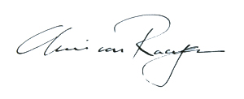
___________________________
Full Name: Chris van Rooyen
Title / Position: Director
Qualification(s): BA LLB
Experience: 17 years

EXECUTIVE SUMMARY

Marang 400/88kV substation is one of the four Main Transmission Substations (MTS), which are currently supplying Rustenburg’s platinum mining, smelting operations and commercial operations. The substation is supplied via the 3 x 400kV power lines, i.e., Matimba-Marang, Bighorn-Marang and Midas-Marang. It comprises of 4 x 315 MVA, 400/88kV transformers and has a capacity of 945 MVA. The recorded peak load was 776MVA in years 2010/11 and 694MVA in years 2011/12. As a result, the Marang 400/88kV will exceed the 400/88kV firm capacity limit by 2015/16. To address these transformation capacity constraints and to align with the 20 year load forecast, Eskom will require a new substation site since the existing substation has space limitations for an extension. Eskom therefore intends to construct and operate a new substation, Marang B 400/132kV and ± 2 km, 400kV power line from the existing Bighorn-Marang or Medupi-Marang 400kV power line.

CONCLUSIONS

The construction of the proposed new Marang B substation and associated power line will pose a limited threat to the birds occurring in the vicinity of the new infrastructure, largely due to the extensive impacts already evident at the site, and the short length of the proposed power line. The power line poses a low collision risk, mostly to non-Red Data species but no electrocution risk. The impact of displacement due to habitat transformation will have a low impact, and should only affect a few non-Red Data species at a local level. Because the habitat at all the proposed alternative substation sites and power line corridors is essentially similar, consisting of open, moderate to heavily disturbed woodland, no preferred alternative is evident from an avifaunal impact perspective. All the site and corridor alternatives are essentially similar in terms of potential risk to avifauna. All the sites and corridors are therefore regarded as potentially viable alternatives from an avifaunal impact perspective.

RECOMMENDATIONS

The vegetation clearing should be restricted to what is absolutely necessary, in order to minimize the impact on the natural woodland habitat. Strict adherence to Eskom standards and specifications is required, specifically:

- Section 4 (Environmental) of the Transmission Specification: Transmission Line Towers and Line Construction Ref: TRMSCAAC1 rev 3 (revised March 2003), and
- Standard for Bush Clearance and Maintenance within Overhead Power line Servitudes Ref: ESKASABG3 rev 1 (revised May 2003)

- INTRODUCTION & BACKGROUND

Marang 400/88kV substation is one of the four Main Transmission Substations (MTS), which are currently supplying Rustenburg’s platinum mining, smelting operations and commercial operations. The substation is supplied via the 3 x 400kV power lines, i.e., Matimba-Marang, Bighorn-Marang and Midas-Marang. It comprises of 4 x 315 MVA, 400/88kV transformers and has a capacity of 945 MVA. The recorded peak load was 776MVA in years 2010/11 and 694MVA in years 2011/12. As a result, the Marang 400/88kV will exceed the 400/88kV firm capacity limit by 2015/16. To address these transformation capacity constraints and to align with the 20 year load forecast, Eskom will require a new substation site since the existing substation has space limitations for an extension. Eskom therefore intends to construct and operate a new substation, Marang B 400/132kV and ±2km, 400 kV power line from the existing Bighorn-Marang or Medupi-Marang or Marang-Midas 400kV power lines.

The proposed project entails the construction and maintenance of the following:

- A new 3x 500MVA 400/132kV Main Transmission Substation (MTS), Marang B on approximately ±30 hectares; and
- The construction of ±2km of 400kV loop in loop out power lines which will feed off the existing 400 kV Bighorn-Marang, Medupi-Marang or Marang-Midas power lines and feed into the new substation.

The proposed project will be in close proximity to the existing 400/88kV Marang Main Transmission substation on Farm Klipgat 281 JQ and Portion 2 of the Farm Elandsheuvel 282 JQ.

Concern was expressed by Eskom that the proposed infrastructure will impact on birdlife and an impact study was therefore requested to investigate the extent of the risk. The terms of reference for the study are as follows:

- Describe the affected environment.
- Indicate how birdlife will be affected.
- Discuss gaps in baseline data.
- List and describe the expected impacts.
- Assess and evaluate the potential of impacts.
- Recommend relevant mitigation measures.

Maps of the study area are presented below in Figures 1 and 2 below.

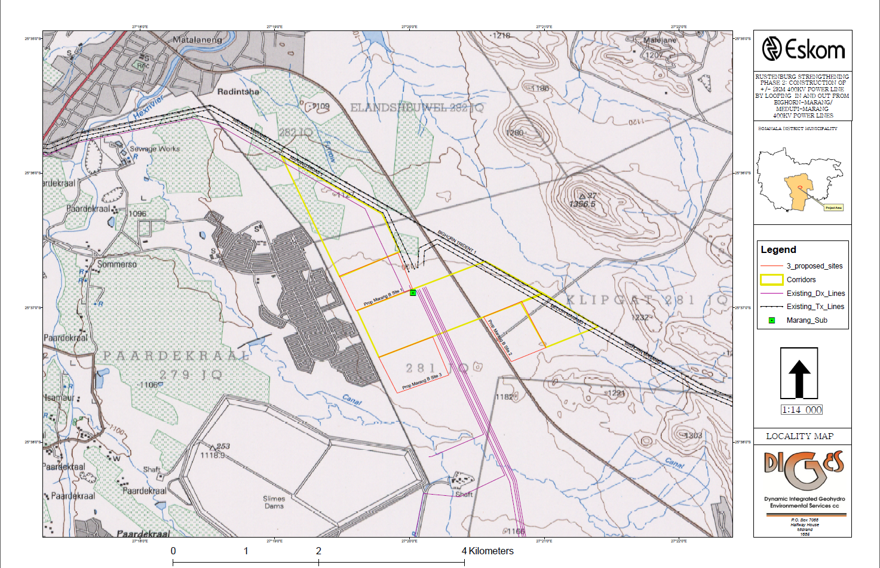
Figure 1: Map of the three proposed Marang B substation alternatives, indicating existing infrastructure and landscape features.

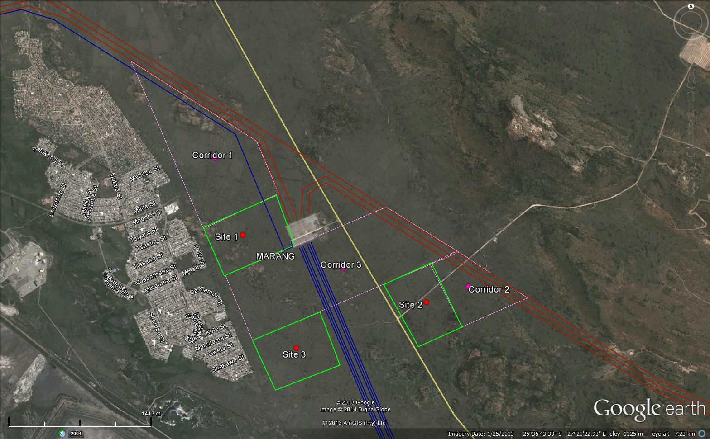
Figure 2: A closer view of the proposed Marang B substation site alternatives and proposed power line corridors, on a background of satellite imagery.
2. SOURCES OF INFORMATION

The following information sources were consulted in order to compile this report:
- Bird distribution data of the Southern African Bird Atlas Project 2 (SABAP2)(http://sabap2.adu.org.za) was obtained for the pentads where the project is located, namely 2535_2715 and 2535_2720. A pentad covers 5 minutes of latitude by 5 minutes of longitude. Each pentad is approximately 8 × 7.6 km.
- The conservation status of all species considered likely to occur in the area was determined as per the most recent iteration of the southern African Red Data list for birds (Barnes 2000), and the most recent and comprehensive summary of southern African bird biology (Hockey et al. 2005).
- The author has travelled and worked extensively on power line projects in the North-West Province since 1996. Personal observations of avifauna and bird/habitat associations have therefore also been used to supplement the data that is available from SABAP2, including observations made during the field trip in October 2013.
- The power line bird mortality incident database of the Eskom - Endangered Wildlife Trust Strategic Partnership (1996 to 2008) was consulted to determine which of the species occurring in the study area are typically impacted upon by power lines and the extent to which they are impacted on (Van Rooyen 2007; Jenkins et al. 2010).
- A classification of the vegetation types in the QDGC where the proposed development is situated, namely 2527CA, was obtained from the Southern African Bird Atlas Project 1 (SABAP1, Harrison et al. (1997) and the Vegetation Map of South Africa (Mucina & Rutherford 2006).
- Information on the location of vulture restaurants was obtained from Kerri Wolter, independent vulture researcher and director of the Vulture Conservation Programme (Vulpro), an NGO dedicated to vulture conservation (Wolter 2012).
- Information on the micro habitat level was obtained through visiting the sites in October 2013 and obtaining a first-hand perspective.

2.2 Assumptions & Limitations

The following assumptions and limitations are applicable in this study:

- In this instance the 2535_2715 and 2535_2720 pentads were reasonably well covered by SABAP2, with data recorded on 9 and 8 data cards respectively to date. This means that the species diversity and densities recorded by SABAP2 provides a fairly accurate picture of the avifauna potentially occurring in the study area. Where necessary, the list of Red Data species that could be encountered was supplemented with observations and general knowledge of the area.
- Conclusions in this report are based on experience of these and similar species in different parts of South Africa. Bird behaviour can never be entirely reduced to formulas that will hold true under all circumstances. However, power line and substation impacts can be predicted with a fair amount of certainty (see References Section 6).
- It is important to note that, although the predicted impacts are mostly concerned with Red Data species, the non-Red Data species should also benefit from the proposed mitigation measures as they share the same habitat and face the same potential impacts as the Red Data species.

- DESCRIPTION OF AFFECTED ENVIRONMENT

2.1 Relevant bird populations

A total of 186 species were recorded in 2535_2715 by SABAP2, with 4 classified as Red Data species (Barnes 2000). In 2535_2720, a total of 144 species were recorded, none of which are currently classified as Red Data species. Reporting rates are an indication of the relative density of a species on the ground in that it reflects the number of times that a species was recorded relative to the total amount of cards that were completed for the pentad.

Table 1 provides a guideline of the species that could potentially be encountered anywhere within a pentad where suitable habitat is available, and should therefore not be used as a measure of actual densities along the proposed power line alignments. The likelihood of it occurring along any of the alignments/ substation sites are covered in the last column.

TABLE 1: Red Data species potentially occurring in 2535_2715 and 2535_2720. NT = Near threatened, VU = Vulnerable

Species | Conservation  Status (Barnes 2000) | Potential habitat in the 2530_2710 pentad  (Harrison et al. 1997, Barnes 2000, Hockey et al. 2005, personal observations) | SABAP2  Reporting  rate 2535_2715  (%) | SABAP2  Reporting  rate 2530_2720  (%) | Likelihood of interaction with proposed infrastructure
YELLOW-BILLED STORK  Mycteria ibis | NT | Rivers, dams. No suitable habitat at the site, likely to occur at the Bospoort Dam, approximately 4km north of the site. | 11 | - | Negligible
RED-BILLED OXPECKER  Buphagus erythrorhynchus | NT | Woodland, in association with cattle. | - | - | Negligible
SECRETARYBIRD  Saggitarius serpentarius | NT | Open woodland and old lands. Could occur anywhere, but high level of urbanization will act as deterrent. | - | - | Low
GREATER FLAMINGO  Phoenicopterus ruber | NT | Open shallow, eutrophic wetlands. Probably occurs regularly at Bospoort Dam. No suitable habitat at site itself. | 11 | - | Negligible
LESSER FLAMINGO  Phoenicopterus minor | NT | Open shallow, eutrophic wetlands. Probably occurs regularly at Bospoort Dam. No suitable habitat at site itself. | 22 | - | Negligible
LANNER FALCON  Falco biarmicus | NT | Generally prefers open habitat, but exploits a wide range of habitats. Could be encountered anywhere in the study area, even in industrial areas. | 11 | - | Medium
YELLOW-THROATED SANDGROUSE  Pterocles gutturalis | NT | Grassland, arable lands on black turf soil. Could be encountered anywhere in open woodland and old lands. | - | - | Low

CAPE VULTURE  Gyps coprotheres | VU | Large cliffs for breeding and roosting, open woodland and grassland. Roosts on transmission lines. Closest breeding colonies are in the Magaliesberg app. 23km south-east at Roberts Farm. Closest vulture restaurant is about 42km away at Mankwe. May fly over the site, but unlikely to feed regularly in the area due to proximity of urban development. | - | - | Negligible
GREATER PAINTED SNIPE  Rostratula benghalensis | NT | Dams, pans and marshy river flood plains. Probably occurs sporadically at Bospoort Dam. No suitable habitat at site itself. | - | - | Negligible
CASPIAN TERN  Sterna caspia | NT | Large water bodies, both natural and man-made, with preference for saline pans and large impoundments. No suitable habitat at the site, likely to occur at the Bospoort Dam | - | - | Negligible
HALF-COLLARED KINGFISHER  Alcedo semitorquata | NT | Fast-flowing streams with clear water and well-wooded banks. Could occur along the Hex River. | - | - | Negligible
AFRICAN MARSH HARRIER  Circus ranivorus | VU | Large permanent wetlands with dense reed beds. Sometimes forages over smaller wetlands and adjacent grassland. Probably occurs sporadically at Bospoort Dam. | - | - | Negligible
LESSER KESTREL  Falco naumanni | VU | Grasslands, old lands, cultivated lands. May occur sporadically. | - | - | Negligible
PINK-BACKED PELICAN  Pelecanus rufescens | V | Wide range of wetlands, lakes dams and slow flowing rivers. Sometimes visit pans in the North-West Province. Occurs sporadically at Bospoort Dam. | - | - | Negligible

  - Vegetation types and bird habitats

The natural vegetation in the study area is Marikana Thornveld, which is open Acacia karroo woodland, with shrubs more dense along drainage lines, on termitaria, rocky outcrops or in other habitats protected from fire (Mucina & Rutherford 2006). In the study area, the woodland consists mostly of short trees and shrubs, with and extensive but heavily grazed grass understorey. It is generally accepted that vegetation structure, rather than the actual plant species, influences bird species distribution and abundance (Harrison et al. 1997). Therefore, the vegetation description below does not focus on lists of plant species, but rather on factors which are relevant to bird distribution. The classification used in this report makes extensive use of the work of Harrison et al. (1997). The criteria used by the atlas authors to amalgamate botanically defined vegetation units, or to keep them separate were (1) the existence of clear differences in vegetation structure, likely to be relevant to birds, and (2) the results of published community studies on bird/vegetation associations.

The 2527CB quarter degree grid cell, where the study area is situated, is comprised entirely of woodland (See TABLE 2 below).

TABLE 2: Vegetation types in 2527CB (Harrison et al. 1997)

Biome | Vegetation type | 2527AC
Savanna | Arid Woodland | 46%
Savanna | Moist Woodland | 54%

Woodland (or savanna) is the dominant natural vegetation type in the study area and it is defined as having a grassy under-storey and a distinct woody upper-storey of trees and tall shrubs (Harrison et al. 1997). Soil types are varied but are generally nutrient poor. The savanna biome contains a large variety of bird species (it is the most species-rich community in southern Africa) but very few bird species are restricted to this biome. It is also relatively well conserved compared to the grassland biome. The savanna biome is particularly rich in large raptors, and forms the stronghold of Red Data species such as White-backed Vulture Gyps africanus, Cape Vulture, Martial Eagle Polemaetus bellicosus, Tawny Eagle Aquila rapax, Bateleur Terathopius ecaudatus, and Lappet-faced Vulture Torgos tracheliotis. Apart from Red Data species, it also serves as the stronghold of several non-Red Data raptor species, such as the Brown Snake Eagle Circaetus cinereus, Black-chested Snake Eagle Circaetus pectoralis, and a multitude of medium-sized raptors for example the migratory Steppe Buzzard Buteo vulpinus, African Harrier Hawk (Gymnogene) Polyboroides typus, Wahlberg’s Eagle Aquila wahlbergi and African Hawk Eagle Aquila spilogaster. Apart from raptors, woodland in its undisturbed state is suitable for a wide range of other power line sensitive birds, including the Kori Bustard Neotis kori.

The study area is situated within a 50km radius of two Important Bird Areas (IBA) namely SA025 (Magaliesberg and Witwatersberg), and SA023 (Pilanesberg) (Barnes 1998). The Magaliesberg forms the core of the Magaliesberg and Witwatersberg IBA. The area north of Rustenburg towards Pilanesberg, particularly those areas that belonged to the former Bophutatswana homeland, has extensive populations of livestock, particularly donkeys, and carcasses of the latter are scavenged by Cape Vultures (personal observation). Pilanesberg IBA is important in that it represents a large, well-managed protected area. It has extensive populations of waterbirds, centred on the Mankwe River and dam. It is also an important draw card for raptors, and has an active vulture restaurant that attracts Cape Vultures, Lappet-faced Vultures and White-backed Vultures (Wolter 2012). Kori Bustard are also recorded in the open woodland in the centre of the park (Barnes 1998). It is not envisaged that the proposed development will have a direct impact on any of the two IBAs.
SA023

The habitat at all the proposed alternative substation sites and power line corridors is essentially similar, consisting of open, moderate to heavily disturbed woodland. The vegetation shows clear signs of sustained high stocking rates which in turn has led to a depletion of the grass layer. The woody component is more intact and consists mostly of small trees and shrubs. The vegetation is less disturbed in rocky areas – there is a rocky area in the northern section of Corridor 1 where the vegetation is relatively intact. However, this will not make a material difference as far as the avifauna that is likely to occur in the study area is concerned, due to the small size of the rocky areas.

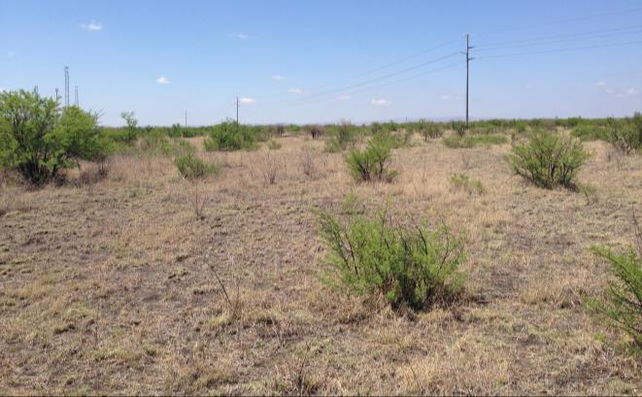
Figure 3: The habitat at Site 1 of the proposed Marang B substation.

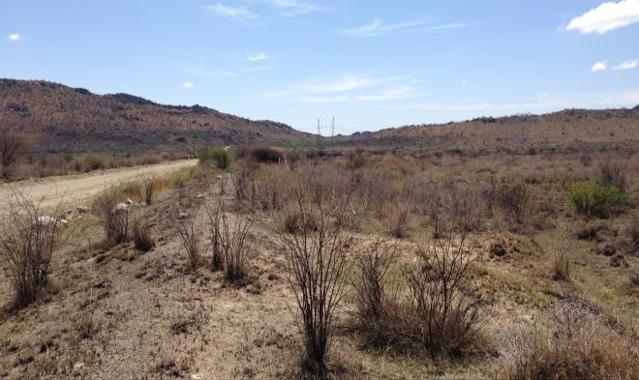
Figure 4: The habitat at Site 2 of the proposed Marang B substation.
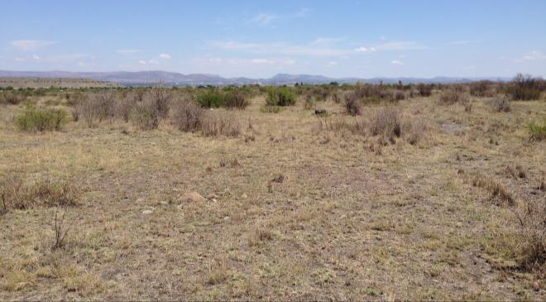
Figure 5: The habitat at Site 3 of the proposed Marang B substation.

3. ASSESSMENT OF IMPACTS

Because of their size and prominence, electrical infrastructures constitute an important interface between wildlife and man. Negative interactions between wildlife and electricity structures take many forms, but two common problems in southern Africa are (a) electrocution of birds and other animals and (b) birds colliding with power lines (Ledger & Annegarn 1981; Ledger 1983; Ledger 1984; Hobbs & Ledger 1986a; Hobbs & Ledger 1986b; Ledger et al. 1992; Kruger & Van Rooyen 1998; Van Rooyen 1998; Kruger 1999; Van Rooyen 1999; Van Rooyen 2000, Anderson 2001; Van Rooyen 2007; Jenkins et al. 2010). Other problems include electrical faults caused by bird excreta when roosting or breeding on electricity infrastructure (Van Rooyen et al. 2002), and displacement through disturbance and habitat destruction during construction and maintenance activities.

3.1 Displacement due to loss of breeding, foraging and roosting habitat through habitat transformation.
During the construction phase and maintenance of power lines and substations, some habitat destruction and alteration inevitably takes place. This happens with the construction of access roads, and the clearing of servitudes. These activities have an impact on birds breeding, foraging and roosting in or in close proximity of the site, through the modification of habitat.

Historically, i.e. before the establishment of the current settlements and industrial activity the area surrounding the proposed Marang B substation site and associated power line must have comprised entirely of undisturbed woodland. As a result it would most likely have supported a number of power line sensitive Red Data species, particularly raptor species such as Martial Eagle, Tawny Eagle, Bateleur, Lappet-faced Vulture and also non-raptors such as Kori Bustard. However this area is rapidly transforming to accommodate a change in land use (i.e. industrial and human settlement) which reduced the number and variety of species originally inhabiting the area, on account of the loss of habitat and decline in food availability. The clearing of woodland (mostly woody shrub) under the new proposed power line should have a limited impact, because of the small length of the line (only 2km), and because of the extensive impacts already evident in the area e.g. there are already 10 high voltage lines running through the study area, which have resulted in the clearing of large areas of woodland in the area around Marang substation. It is not envisaged that any Red Data species will be displaced by the habitat transformation that will take place as a result of the construction of the proposed 2km power line, irrespective of which corridor is used. The impact on smaller, non-Red Data species that are potentially breeding in the area that will be cleared for the new power lines will be local in extent, in that it will not affect regional or national populations in any significant way. The construction of the proposed new power line should therefore have a LOW displacement impact from an avifaunal perspective. It must be noted though that the impact of development, particularly mining, urbanisation and the associated infrastructure in the area between Rustenburg and Pilanesberg is leading to an increase in disturbance levels and fragmentation of habitat. This in turn is almost certainly impacting on several species of birds, including Secretarybirds and other large raptors, and this is likely to increase in future.

The habitat at the proposed Marang B substation sites, namely heavily disturbed woodland, do not contain unique features that will make it critically important for the Red Data species listed in Table 1. This habitat is common in the area and due to the high level of impacts already evident at the sites; the Red Data species listed in Table 1 are unlikely to be attracted to the area. The species (if any) that will be affected by the loss of habitat are the smaller, non-threatened passerines that are currently potentially resident in the patch of heavily disturbed woodland that will be taken up by the substation. It is not envisaged that any Red Data species will be permanently displaced by the habitat transformation that will take place at the area comprising the proposed substation site, irrespective of which site is used. The construction of the proposed Marang B substation should therefore have a LOW displacement impact from an avifaunal perspective at any of the alternative sites.

  - Collisions with the proposed power line.
Due to the high level of existing impacts in the study area and the short length of the proposed line it is not expected that the proposed power line will pose a significant collision risk to Red Data species. Very few if any Red Data species is expected to occur in the study area. The collision risk is therefore regarded as LOW.

3.4 Electrocutions on the proposed 400kV power line.
NO electrocution risk is foreseen on the new power line. Transmission lines do not pose an electrocution risk because the clearances between live components or live and earthed components are too big to be bridged by even the largest birds.

4 CONCLUSIONS

The construction of the proposed new Marang B substation and associated power line will pose a limited threat to the birds occurring in the vicinity of the new infrastructure, largely due to the extensive impacts already evident at the site, and the short length of the proposed power line. The power line poses a low collision risk, mostly to non-Red Data species but no electrocution risk. The impact of displacement due to habitat transformation will have a low impact, and should only affect a few non-Red Data species at a local level. Because the habitat at all the proposed alternative substation sites and power line corridors is essentially similar, consisting of open, moderate to heavily disturbed woodland, no preferred alternative is evident from an avifaunal impact perspective. All the site and corridor alternatives are essentially similar in terms of potential risk to avifauna. All the sites and corridors are therefore regarded as potentially viable alternatives from an avifaunal impact perspective.

5 RECOMMENDATIONS

The vegetation clearing should be restricted to what is absolutely necessary, in order to minimize the impact on the natural woodland habitat. Strict adherence to Eskom standards and specifications is required, specifically:

- Section 4 (Environmental) of the Transmission Specification: Transmission Line Towers and Line Construction Ref: TRMSCAAC1 rev 3 (revised March 2003), and
- Standard for Bush Clearance and Maintenance within Overhead Power line Servitudes Ref: ESKASABG3 rev 1 (revised May 2003)

6 REFERENCES

BARNES, K.N. (ed.) 2000. The Eskom Red Data Book of Birds of South Africa, Lesotho and Swaziland. BirdLife South Africa, Johannesburg.

BARNES, K.N. (ed.) 1998. The Important Bird Areas of southern Africa. BirdLife South Africa: Johannesburg.

HARRISON, J.A., ALLAN, D.G., UNDERHILL, L.G., HERREMANS, M., TREE, A.J., PARKER, V & BROWN, C.J. (eds). 1997. The atlas of southern African birds. Vol 1 & 2. BirdLife South Africa, Johannesburg.

HOCKEY P.A.R., DEAN W.R.J., AND RYAN P.G. 2005. Robert’s Birds of Southern Africa, seventh edition. Trustees of the John Voelcker Bird Book Fund, Cape Town.

http://sabap2.adu.org.za. Southern African Bird Atlas Project 2. Accessed on 01 February 2014.

JENKINS, A.R., SMALLIE, J.J. & DIAMOND, M. 2010. Avian collisions with power lines: a global review of causes and mitigation with a South African perspective. Bird Conservation International 20: 263-278.

MUCINA. L. & RUTHERFORD, M.C. (Eds) 2006. The vegetation of South Africa, Lesotho and Swaziland. Strelitzia 19. South African National Biodiversity Institute, Pretoria.

WOLTER, K. 2012. Unpublished vulture restaurant database, 05 November 2012.

VAN ROOYEN, C.S. 2007. Eskom-EWT Strategic Partnership: Progress Report April-September 2007. Endangered Wildlife Trust, Johannesburg.

WOLTER, K. 2012. Unpublished vulture restaurant database, 05 November 2012.

ANDERSON, M.D. 2001. The effectiveness of two different marking devices to reduce large terrestrial bird collisions with overhead electricity cables in the eastern Karoo, South Africa. Karoo Large Terrestrial Bird Power line Project. Kimberley (SA): Directorate Conservation & Environment - Northern Cape. (Eskom Report No. 1).

HOBBS, J.C.A. & LEDGER J.A. 1986a. The Environmental Impact of Linear Developments; Power lines and Avifauna. Proceedings of the Third International Conference on Environmental Quality and Ecosystem Stability. Israel, June 1986.

HOBBS, J.C.A. & LEDGER J.A. 1986b. Power lines, Birdlife and the Golden Mean. Fauna and Flora, 44:23-27.

KRUGER, R. & VAN ROOYEN, C.S. 1998. Evaluating the risk that existing power lines pose to large raptors by using risk assessment methodology: The Molopo Case Study. Proceedings of the 5th World Conference on Birds of Prey and Owls. August 4-8,1998. Midrand, South Africa.

KRUGER, R. 1999. Towards solving raptor electrocutions on Eskom Distribution Structures in South Africa. Bloemfontein (South Africa): University of the Orange Free State. (M. Phil. Mini-thesis)

LEDGER, J. 1983. Guidelines for Dealing with Bird Problems of Transmission Lines and Towers. Eskom Test and Research Division. (Technical Note TRR/N83/005).

LEDGER, J.A. & ANNEGARN H.J. 1981. Electrocution Hazards to the Cape Vulture (Gyps coprotheres) in South Africa. Biological Conservation 20:15-24.

LEDGER, J.A. 1984. Engineering Solutions to the Problem of Vulture Electrocutions on Electricity Towers. The Certificated Engineer, 57:92-95.

LEDGER, J.A., J.C.A. HOBBS & SMITH T.V. 1992. Avian Interactions with Utility Structures: Southern African Experiences. Proceedings of the International Workshop on Avian Interactions with Utility Structures. Miami (Florida), Sept. 13-15, 1992. Electric Power Research Institute.

MARTIN, G., SHAW, J., SMALLIE J. & DIAMOND, M. 2010. Bird’s eye view – How birds see is key to avoiding power line collisions. Eskom Research Report. Report Nr: RES/RR/09/31613.

VAN ROOYEN, C.S. & KRUGER, R. 2003. Vulture electrocutions on vertically configured medium voltage structures in the Northern Cape Province, South Africa in Proceedings of the 6th World Conference on Birds of Prey and Owls May 2003, Budapest, Hungary (R. D. Chancellor, and B.-U. Meyburg, Eds.). World Working Group on Birds of Prey and Owls and MME BirdLife Hungary, Berlin, Germany.

VAN ROOYEN, C.S. & LEDGER, J.A. 1999. Birds and utility structures: Developments in southern Africa. Pp 205-230, in Ferrer, M. & G.F.M. Janns. (eds.). Birds and Power lines. Quercus, Madrid (Spain). Pp 238.

VAN ROOYEN, C.S. 1998. Raptor mortality on power lines in South Africa. Proceedings of the 5th World Conference on Birds of Prey and Owls. Midrand (South Africa), Aug.4 – 8, 1998.

VAN ROOYEN, C.S. 1999. An overview of the Eskom-EWT Strategic Partnership in South Africa. EPRI Workshop on Avian Interactions with Utility Structure.s Charleston (South Carolina), Dec. 2-3 1999.

VAN ROOYEN, C.S. 2000. An overview of Vulture Electrocutions in South Africa. Vulture News, 43: 5- 22. (Vulture Study Group, Johannesburg, South Africa).

VAN ROOYEN, C.S. 2007. Eskom-EWT Strategic Partnership: Progress Report April-September 2007. Endangered Wildlife Trust, Johannesburg.

VAN ROOYEN, C.S. VOSLOO, H.F. & R.E. HARNESS. 2002. Eliminating bird streamers as a cause of faulting on transmission lines in South Africa. Proceedings of the IEEE 46th Rural Electric Power Conference. Colorado Springs (Colorado), May. 2002.

